CS 255 System Design Document

UML Diagrams

UML Use Case Diagram
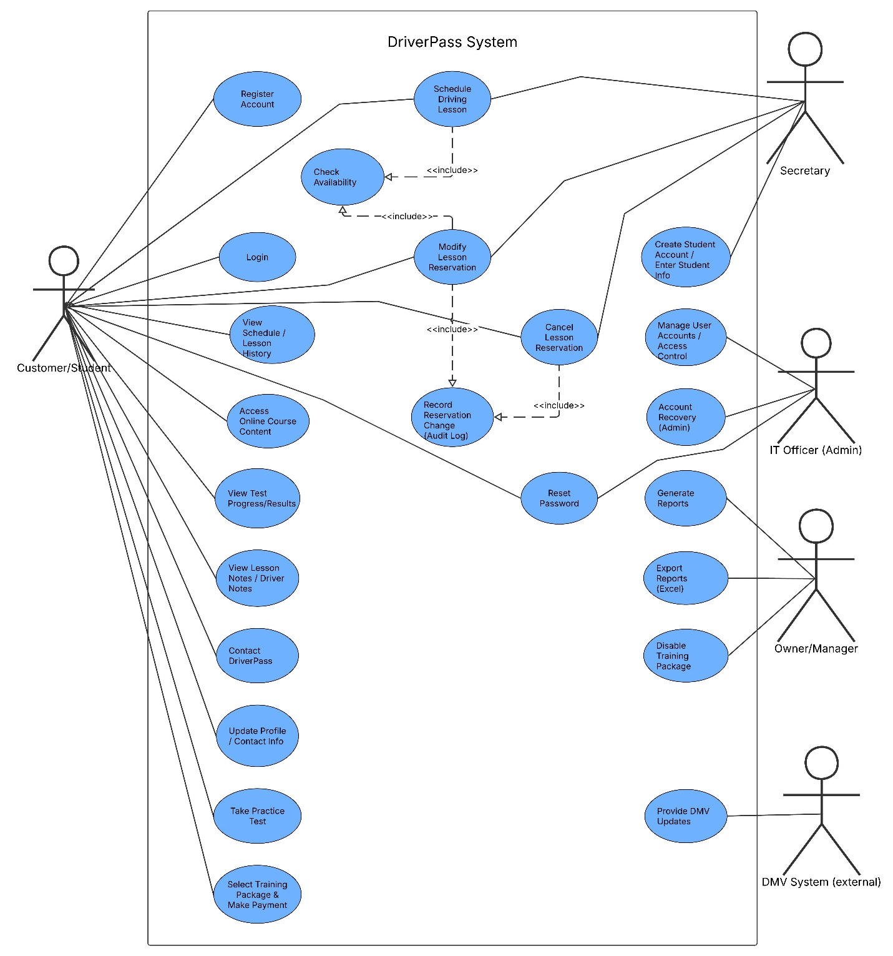

UML Activity Diagrams
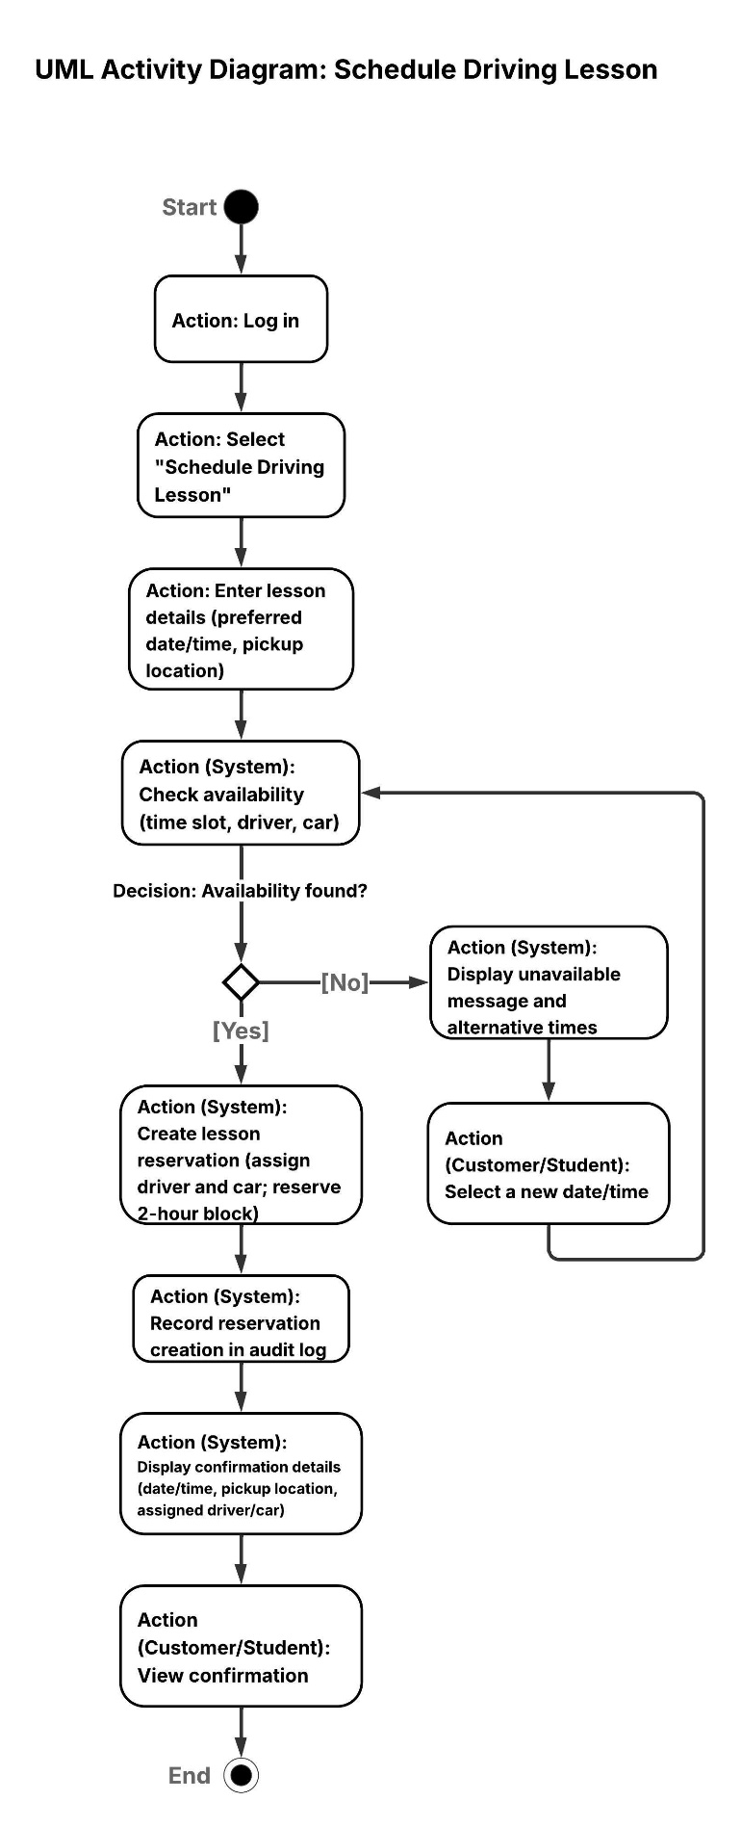
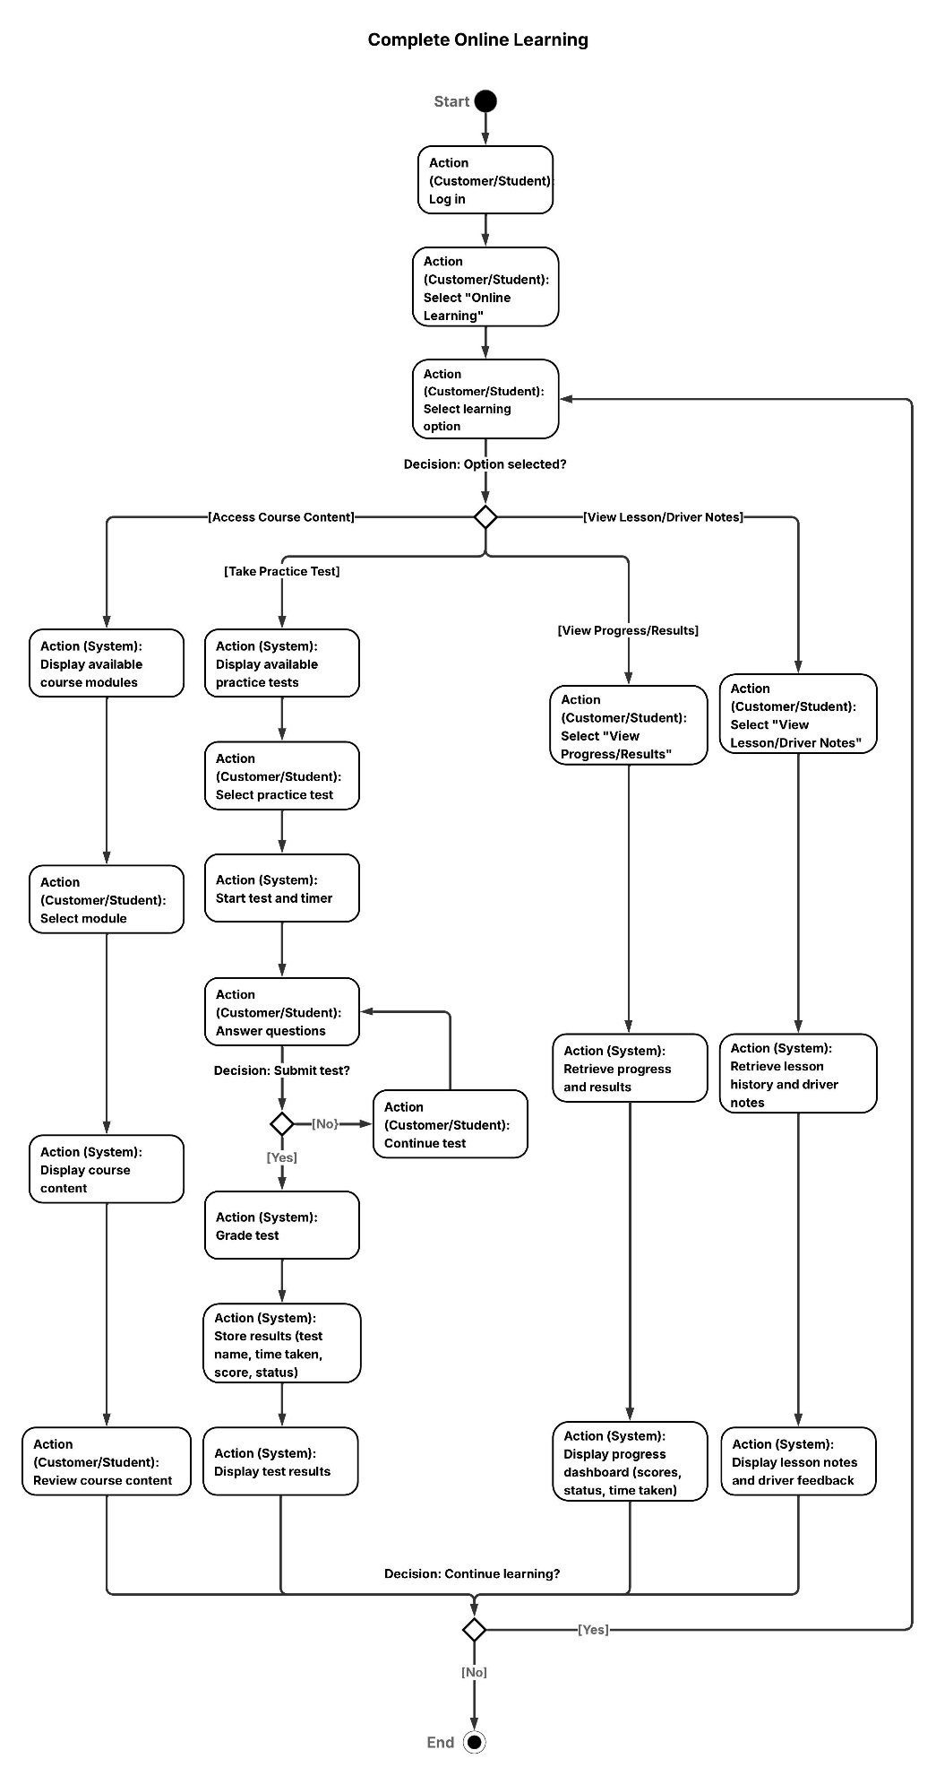

UML Sequence Diagram
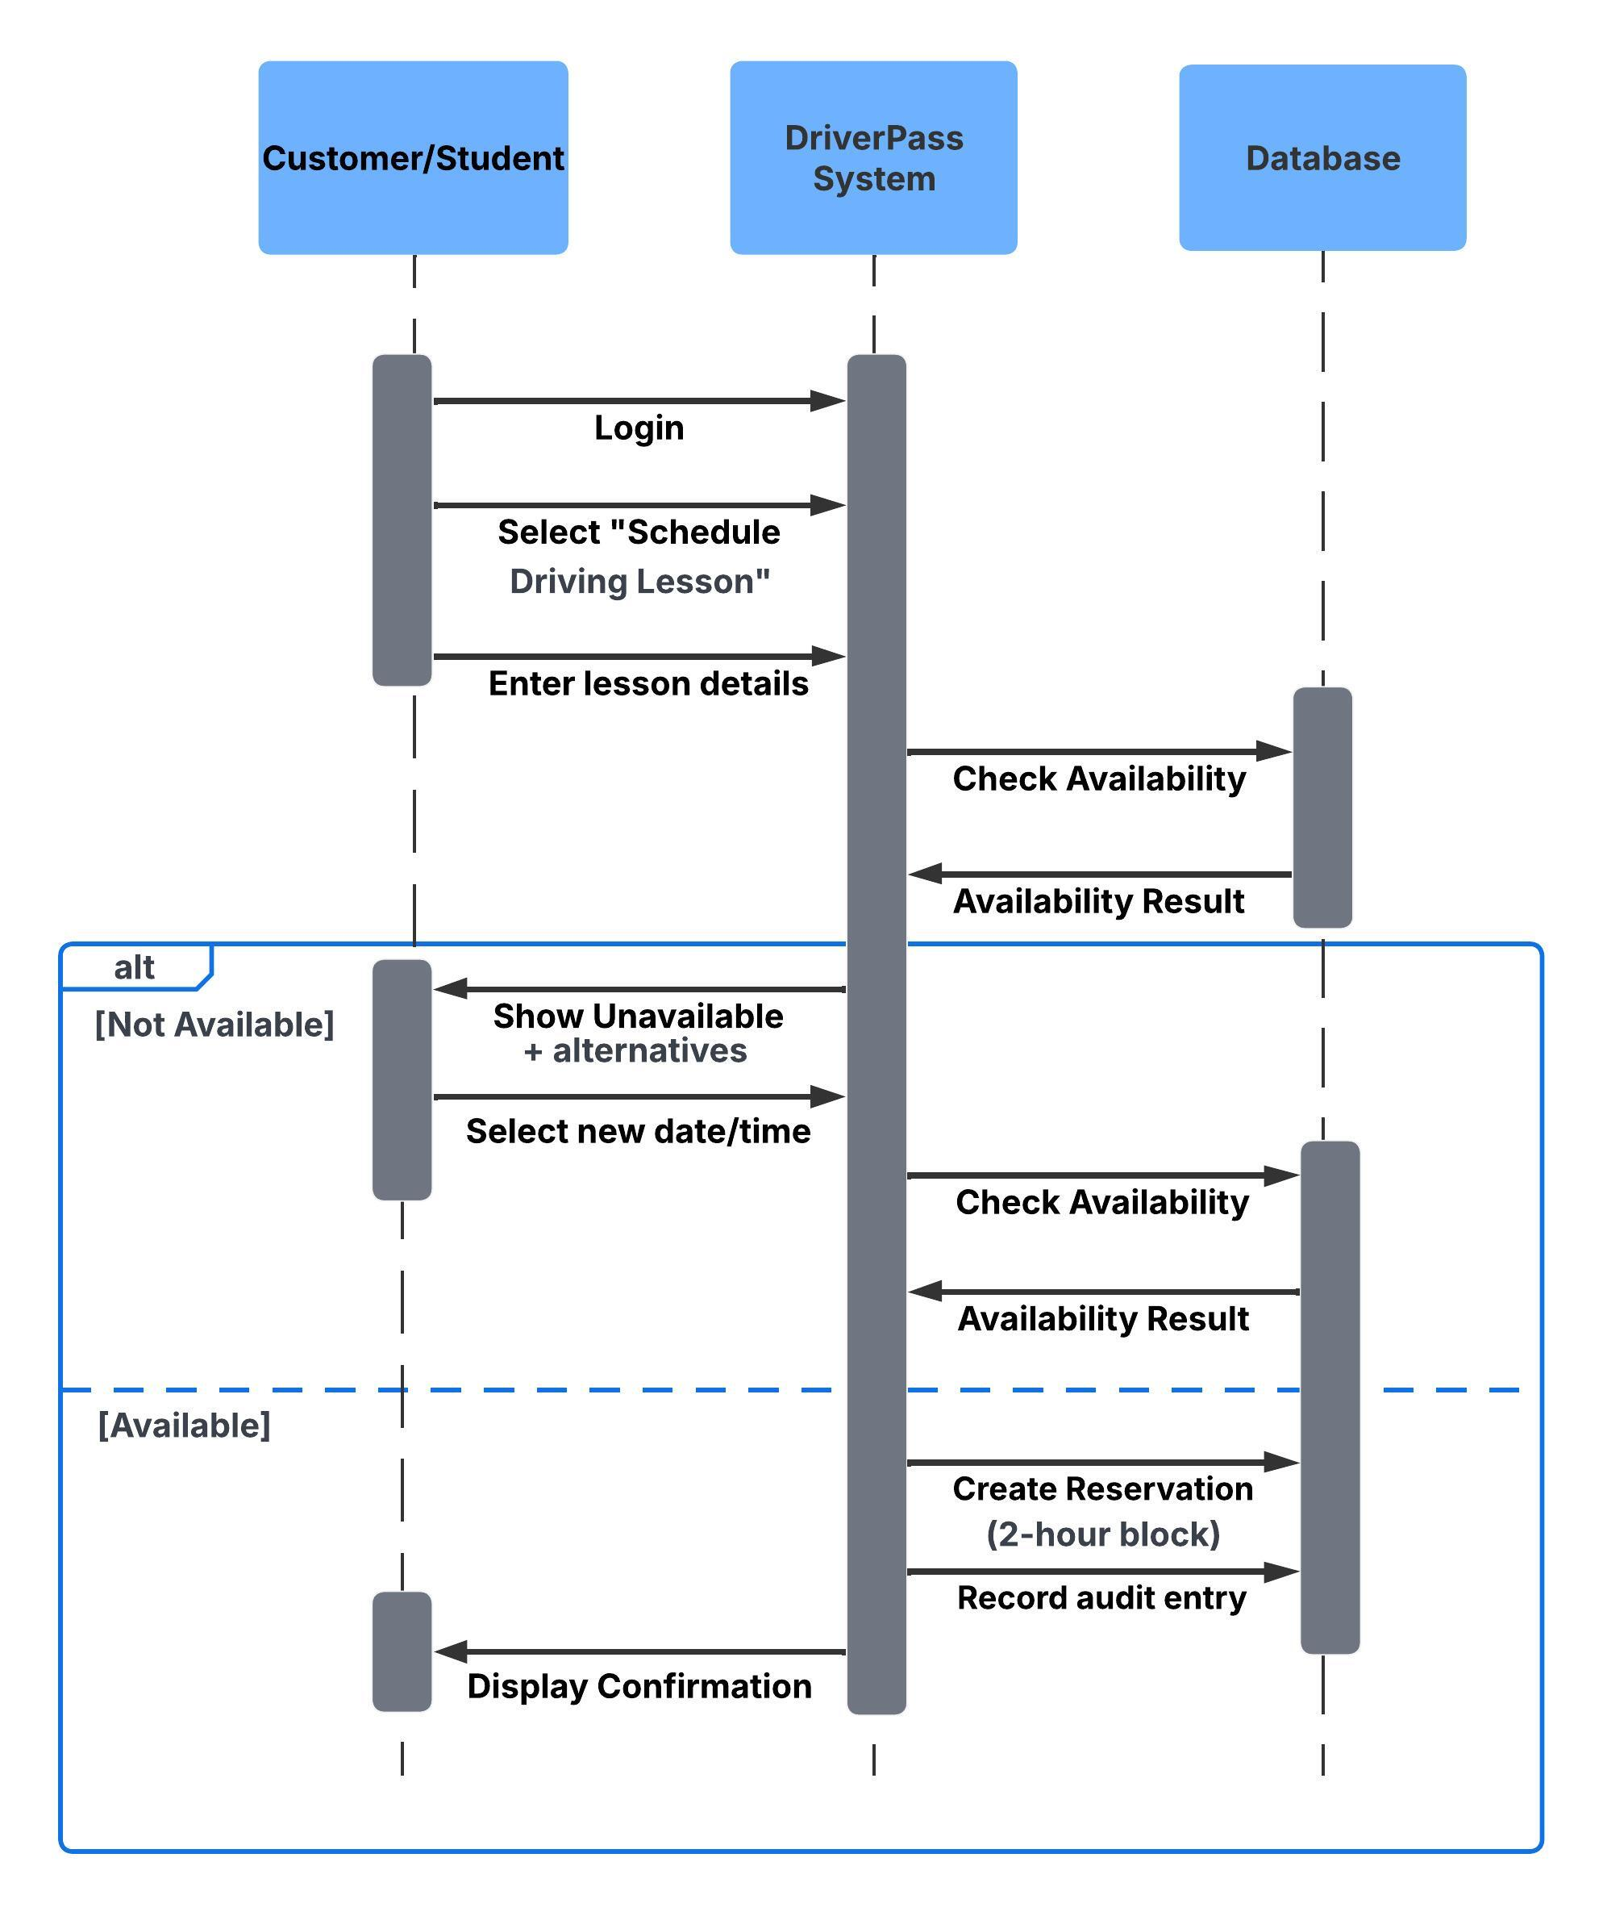

UML Class Diagram
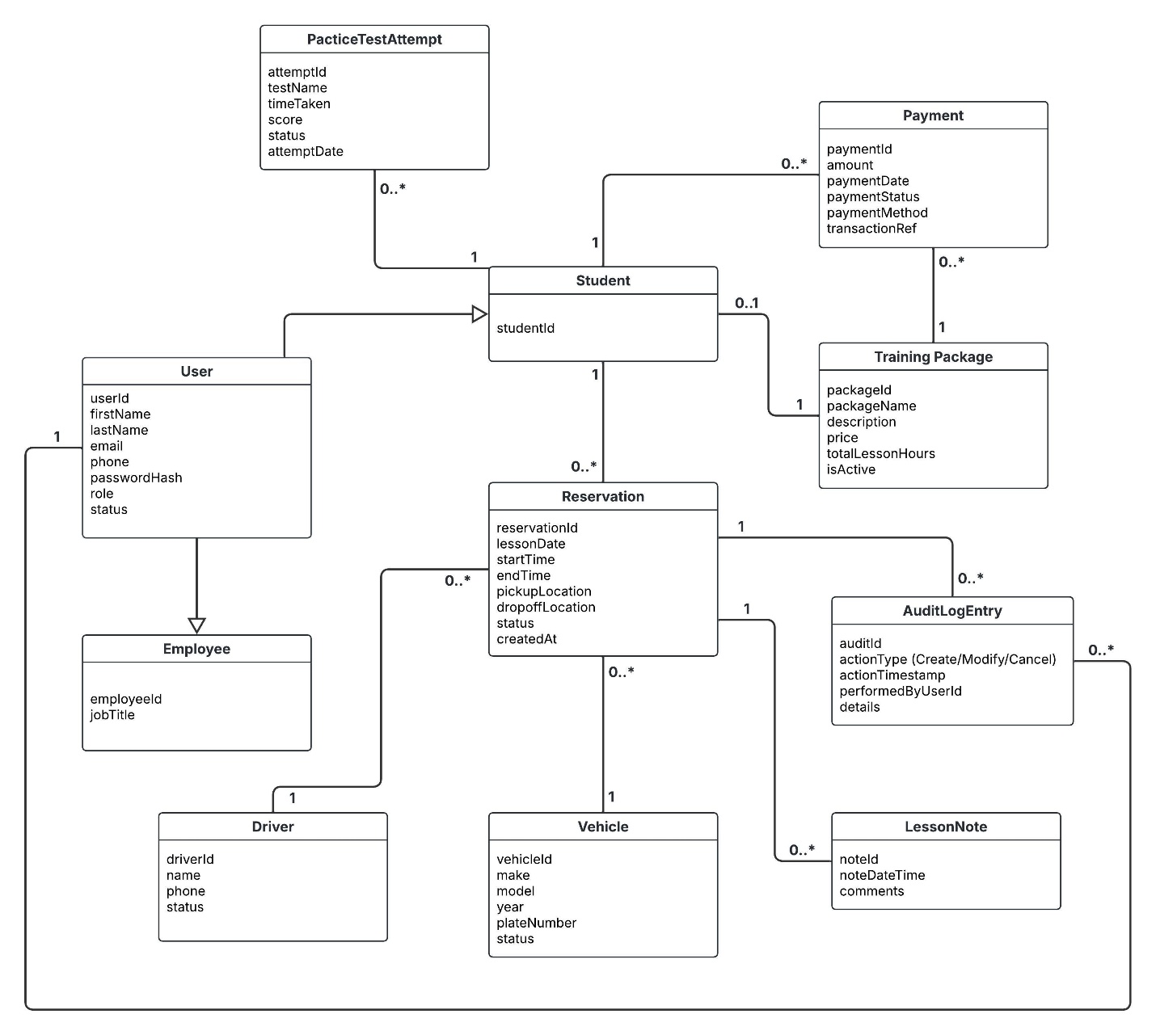

Technical Requirements
Hardware (Client and Office)
- Customer/Student devices: Desktop/laptop/tablet/smartphone capable of running a modern web browser.
- Office staff devices (Secretary/Owner/IT Officer): Desktop or laptop with keyboard/mouse for scheduling and account management tasks.
- Optional peripherals: Printer for printed reports and receipts.
Software
- Web application accessible through modern browsers (Chrome, Edge, Safari) with a responsive layout for mobile use.
- Database system to store user accounts, packages, reservations, vehicles/drivers, practice test results, lesson notes, and audit log entries.
- Reporting/export capability to generate and download reports (e.g., PDF/CSV/Excel format) for business tracking and offline viewing.

Infrastructure / Hosting
- Cloud hosting for the DriverPass web application so customers and staff can access the system from anywhere.
- Reliable internet connection required for account access, scheduling, updates, and saving changes. (Downloaded reports can be viewed offline, but updates require an internet connection.)
- Automated backups and data recovery support to prevent data loss.
- Integration capability to receive DMV updates (via API or scheduled data import) so practice tests and training content stay current.
Security / Access Control
- Role-based access control (RBAC) to restrict features by user type (Customer/Student, Secretary, IT Officer, Owner/Manager).
- Secure authentication and password reset/recovery process.
- Encrypted communication (HTTPS/TLS) for all logins and data transmission.
- Audit logging for reservation creation/modification/cancellation to track who performed actions and when.
- Secure payment handling: payments should be processed using a secure payment workflow and sensitive card data should not be stored directly in the system (store only confirmations/transaction references).
Tools / Administration
- Admin tools for the IT Officer to manage accounts, reset credentials, and disable user access when needed.
- System monitoring/logging to support troubleshooting and uptime reliability.

